Production Document
Codename: Tanks and Tactics

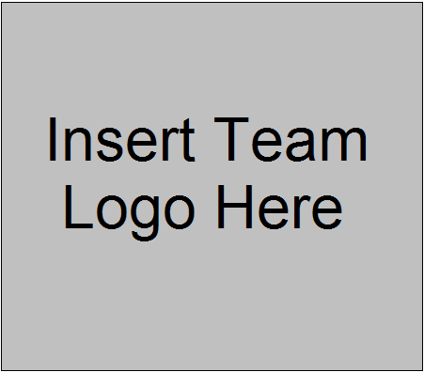

Drew Banyai
drewbanyai@gmail.com
610-613-2516

Table of Contents:

Interactivity
Goal
Interface
Interactive Rhythm
Marking Progress

Design Breakdown
Front End Flow Chart
Battle Flow Chart
Glossary of Terms
Characters
Levels / Maps
Interaction Matrix
Game Algorithms
FAQ

Key Elements
Scoring
Winning / Losing
Transitions
Rewards

Art and Production
3D Art and Animation
2D Art and Animation
Sound Effects
Music

Interactivity

Goal

The goal of the game will be to defeat your opponent in battle, using the units within your Battalion. Each team will control a Battalion, a group of units that has been chosen and customized by each Commander. The units will be controlled each turn, and the choices that each side makes will determine which team is destroyed or incapacitated first. The team that remains while all enemy forces are unable to fight is victorious.

The overall goal of the game will be to be victorious in a number of battles, eventually completing a long-standing mission within the campaign storyline. Throughout the course of the missions, the player will need to use the spoils of war to upgrade the units within their Battalion, and outfit them with better technology while also refining their strategy in combat.

Interface

The interface within the game will be reminiscent of old-school role playing games, where a dialog box would adorn a side of the screen when a unit was selected. The dialog box will contain options of what to do do that unit (or other object that is selected) and will then disappear. The interface, in that way, will be rather simple and minimal when no major action is waiting on an order from the player.

As for menus, a simple menu and transition system will be implemented so that menus can be altered either by the players themselves (Customizing menus will be possible) or by simple patching of an external menu resource file.
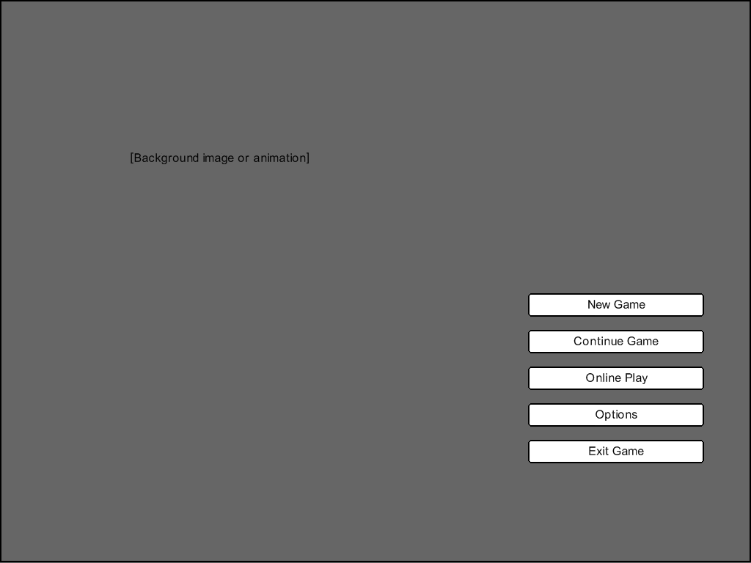
Main Menu (General Look / Feel)

The Main Menu will most likely consist of a simple background image or
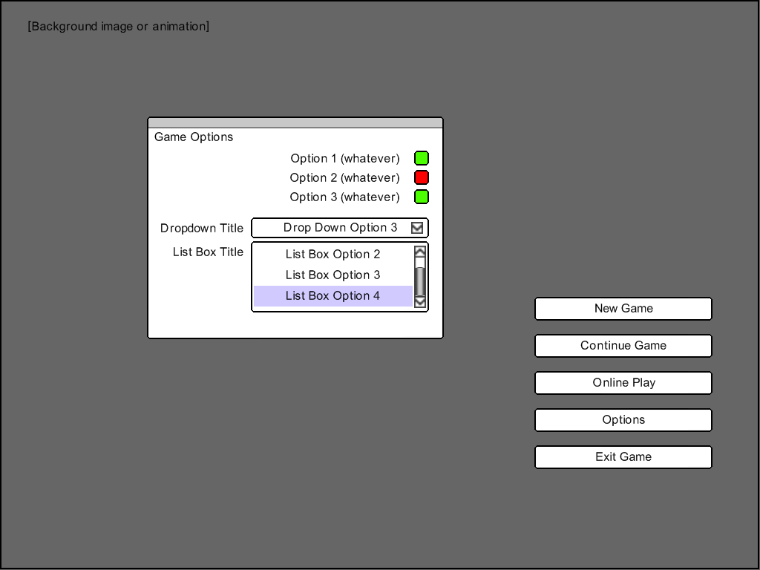
Options Menu (General Look / Feel)

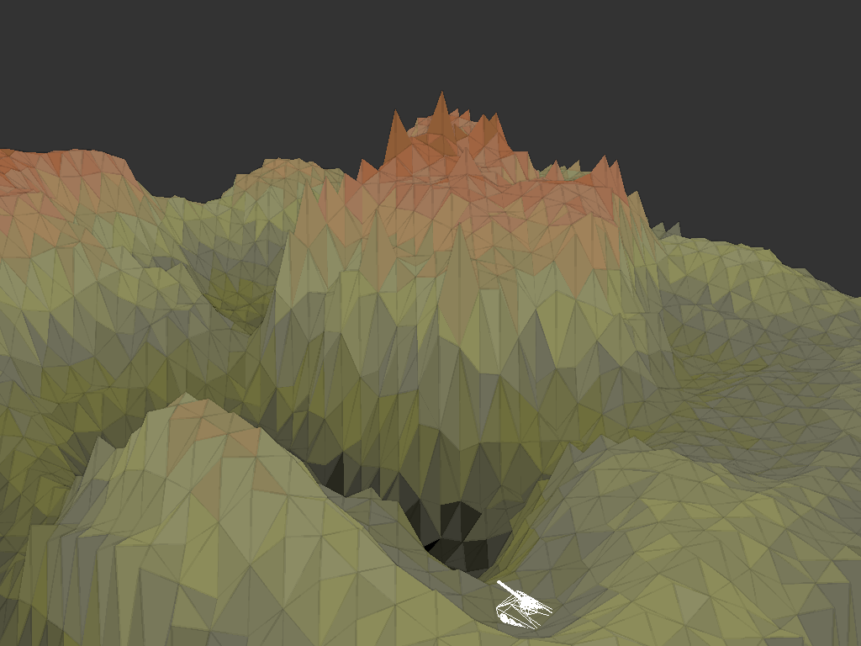
Game World (Without Interface)

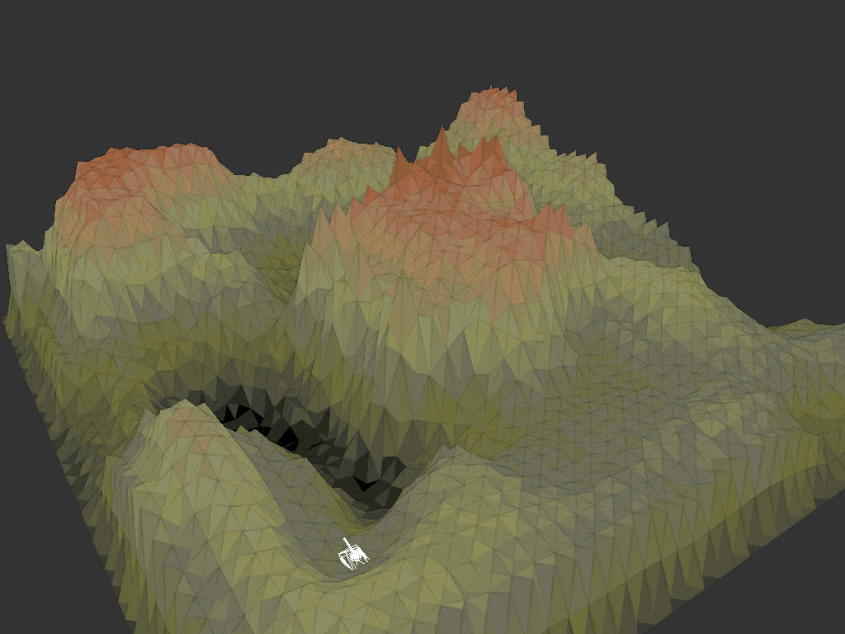
Game World (Without Interface)

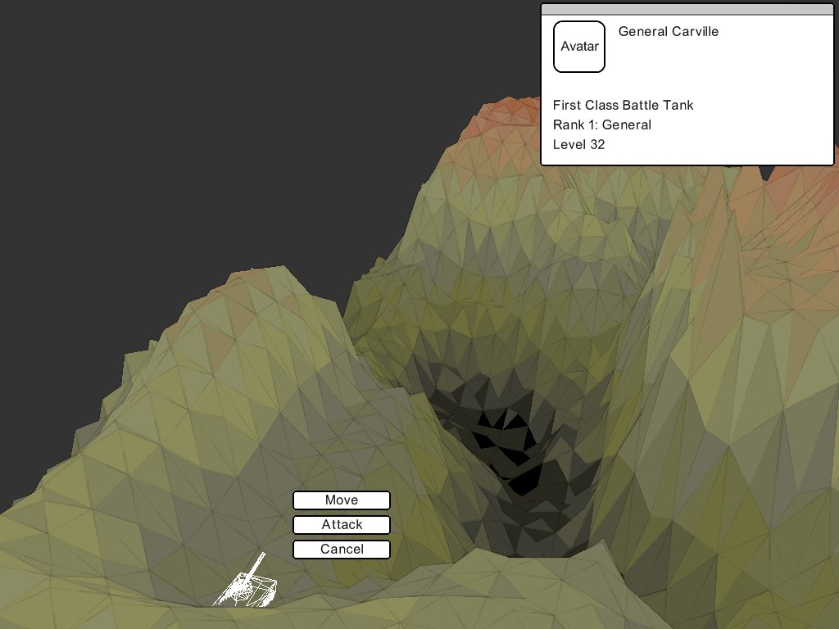
Game World (With Unit Selection Interface Look / Feel)

Basic Controls

The controls themselves are extremely simple. The game can be controlled entirely with either just the mouse or just the keyboard in all cases. Even in the case of string input, since the player will be able to load up an on-screen keyboard whenever a string input box is selected.

Menu Controls
  - Navigation Arrow Keys | W,A,S,D | Mouse Movement
  - Accept Enter / Return | Left Mouse Button
  - Cancel Escape | Right Mouse Button
  - Next Dialog Element Tab | Middle Mouse Button

Combat Controls
  - Camera Navigation W,A,S,D | Mouse Movement (with right mouse button held)
  - Unit Selection Number Key | Left Mouse Button
  - Unit De-selection Backspace | Escape | Right Mouse Button
  - Game Menu Access Escape (when no unit is selected)
  - Next Unit Tab | Middle Mouse Button

Interactive Rhythm

A typical game session can be as short as five minutes, given the following (assumable) scenario:
  - Player 1 logs on, and is taken to his character screen
  - Player 1 chooses a character and is taken to the global view
  - Player 1 chooses a quick-match, which puts him into battle with a person of similar level
  - Player 1 takes turns with Player 2, moving and attacking with the units in their battalions
  - Player 1 destroys the last of Player 2's units. Player 1 is victorious
  - Player 1 is shown a victory screen outlining battle stats and any items or money won
  - Player 1 returns to the global view, and possibly adds Player 2 as a friend
  - Player 1 logs off

Game sessions can go on indefinitely, given a player's desire to engage in typical activities:
  - Increase the power of their units through battle
  - Spend their earned in-game money on new items and upgrades for their battalion
  - Socialize with other players
  - Compete in tournaments
  - Go through mission sets (by themselves or cooperatively with other players)
  - Etc.

Marking Progress

When the Player is victorious in battle, they are awarded with experience for their units, in-game money, items, and sometimes achievements. Units will level up when enough experience is accrued. The units can be upgraded or replaced outside of battle using the in-game money and based on what achievements the Player has received. Based on these gameplay mechanics, the player has a number of things to use for marking progress:
  - The level of their battalion and individual units within it
  - The achievements that they have been awarded
  - Their social standing within the community
  - The amount of in-game money they have
  - The different units they have unlocked through achievements or purchases
  - The customization of their units (abilities / perks / add-ons / novelty visual changes)
  - Their battle statistics (number of victories / losses)

Design Breakdown

Front End Flow Chart

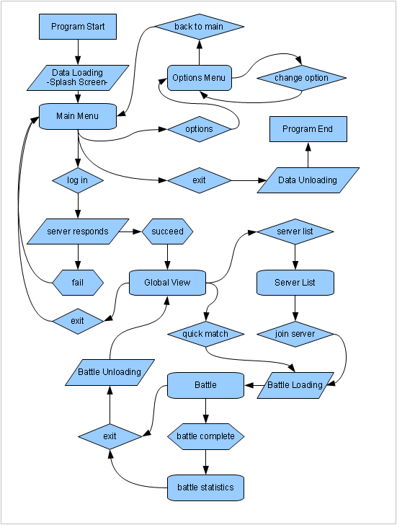

Battle Flow Chart

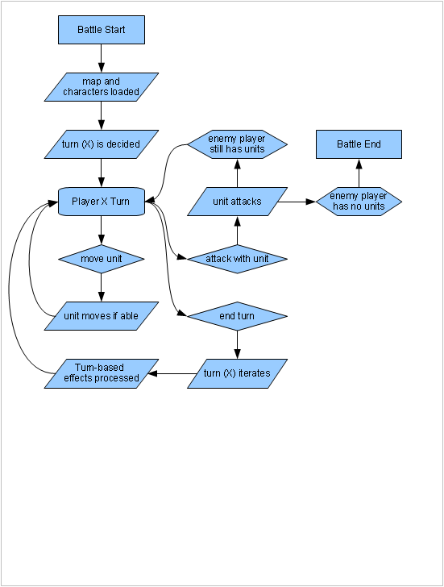

Glossary of Terms

Commander – A human or AI controlled player that controls a Battalion

Battalion – A group of Units under control of a commander

Unit – A single entity within the Battalion, having a type, statistics, and the ability to move and shoot

Mobile Command – The vehicle that houses the battalion, where the Commander communicates with other systems such as the Global Trading Market, Worldwide Supply, Global Recruitment, etc.

Global Tournament – The contest to determine the ranking of Commanders by having them face off in battle against each other (in canon, the battles are simulations)

Global Trading Market – The global market where items, Units, and services are traded

Worldwide Supply – The NPC-driven trading market where necessities are sold to Commanders

Global Recruitment – The NPC-driven recruitment area for gaining new units for your Battalion

Angle – When firing, the angle is the pitch at which the shot is fired (degrees)

Power – When firing the power is the force with which the shot is fired (percent)

Speed – On a Unit, the speed is the amount of spaces that the Unit can move per turn

Damage – On a Unit, the damage is the amount of damage an attack deals before armor calculation

Range – On a unit, the range is the amount of spaces that the unit can attack to

Armor – On a Unit, the armor represents the amount of damage the unit is protected from

Level – On a Unit, the level is a representation of the amount of experience obtained.

Level-Up – When a Unit obtains enough experience, he will rise one level and gain upgrade points

Upgrade Points – On a Unit, this is the number of points that can be used to upgrade the Unit stats

General – One unit per Battalion can be selected as the General. Based on the type and level of the unit, the entire Battalion will gain certain perks

Characters

Strike Buggy
  - High Movement
  - Low Armor
  - Medium Range
  - Low Damage
  - General Bonus: Movement bonus for all units

Strike Tank
  - Moderate Movement
  - High Armor
  - Moderate Range
  - Moderate Damage
  - General Bonus: Armor bonus for all units

Mobile Rocket Launcher
  - Low Movement
  - Low Armor
  - High Range
  - High Damage
  - General Bonus: Commander has a bombing attack power every X turns (based on level)
  - Ability: Drop payload (becomes a remote detonation bomb) and increase movement

Mobile Technician
  - Moderate Movement
  - Moderate Armor
  - Low Range
  - Low Damage
  - General Bonus: Commander can repair friendly units X amount (based on level)
  - Ability: Heal friendly units

Fire Bug
  - High Movement
  - Low Armor
  - Low Range
  - High Damage
  - General Bonus: After combat, any unit killed by the Fire Bug gives a money bonus
  - Ability: Napalm bomb covers a small area with damage-over-time

Levels / Maps

The maps can be loaded either through an entire map file (where the entire map is specifically created and has no random attribute) or from a process that creates a map based on a choice few arguments. In online ladder games, the server will randomly generate a map and send the information down to all players involved with the battle. In that way, the battle will be played on a field that no one will have knowledge of beforehand. Also, the random factor will make special items and features in maps unknown, so strategies will have to be determined on the fly once the battle begins.

The maps are composed of very simple data. A height-map controls the shape of the map and where the units can move to and from. The spaces in between those points are smoothed over with triangles, which serve no purpose except cosmetically, since units will roll over areas as if they were a hillside or something similar. The theme of the map will control the color of the triangles, which alters based on the height of the triangle, with a small bit of random calculation to make the map seem more natural.

There will be special item package objects that sometimes appear within maps. A player can destroy the object to get the item inside. During ladder matches, these items will be secondary objectives, since you can not keep an item you received in a battle if you are not victorious.

Switching out map types changes their color palette so that a new ambiance is achieved. The following three pictures show one map with three different types. Note that the maps have no effects applied, or objects within (except a test tank wireframe for perspective purposes).

